Tren android studio khong can phai download google playservice ma dung

**compile 'com.google.android.gms:play-services-ads:8.1.0'**

Vao project chon Gradle Scripts -> build.gradle va bo xung cau tren vao phan compile nhu hinh, xong thi nhan Sync Now

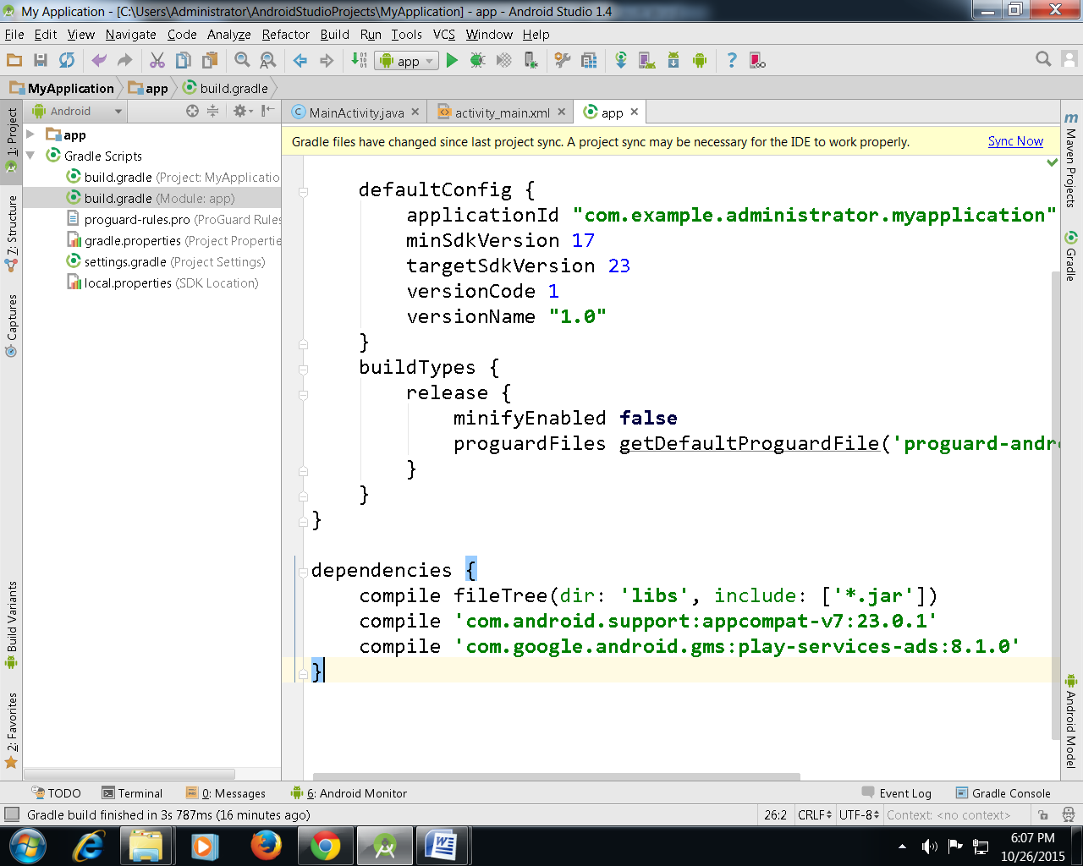

Tham khao them

https://developers.google.com/admob/android/quick-start